int sensor_pin = A0;
int output_value ;
void setup()
{
Serial.begin(9600);
Serial.println("Reading From the Sensor ...");
delay(2000);
}
void loop() {
output_value= analogRead(sensor_pin);
output_value = map(output_value,550,0,0,100);
Serial.print("Mositure : ");
Serial.print(output_value);
Serial.println("%");
delay(1000);
}
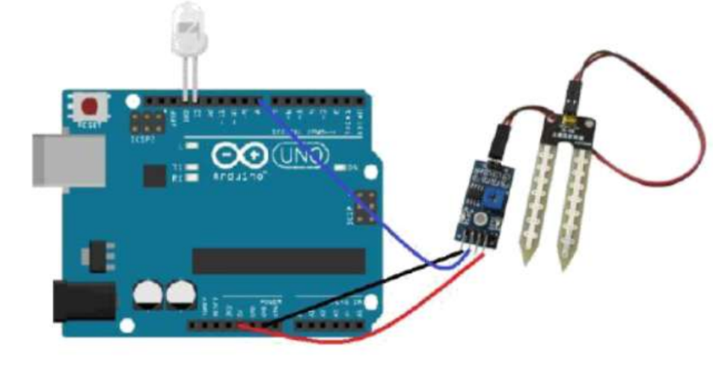
- VCC → 5V
- GND → GND
- AO → A0

